
THE ISLAMIA UNIVERSITY OF BAHAWALPUR.
Department of Information and Technology
Faculty of Computing

Submitted To: Supervisor Dr. Omar Riaz
Submitted By: Muhammad Zohaib Rasool
Roll No. (S23BINFT1M01200)
Section: 2M (7th Semester)
Submission Date: 30th April, 2026

Smart Attendance System Using Facial Recognition

Summary

This Software Requirements Specification (SRS) document presents a comprehensive description of the Smart Attendance System using Facial Recognition, an AI-powered solution designed to modernize and automate attendance management in educational institutions and professional environments. Traditional attendance methods—such as manual roll calls, signature sheets, and RFID cards—are often time-consuming, inaccurate, and vulnerable to proxy attendance. The proposed system eliminates these limitations by integrating computer vision and artificial intelligence to provide a highly reliable, contactless, and efficient attendance-taking mechanism.

The system operates by utilizing a standard laptop or desktop webcam to capture real-time video input. Through the use of Python, OpenCV, and the face_recognition library, the system performs face detection, extracts unique facial features, and matches them with a pre-registered student database. When a match is found, attendance is recorded automatically along with essential metadata such as the student's name, roll number, date, and timestamp.

The project also incorporates features such as student registration, dataset creation, attendance storage using SQLite or CSV files, and generation of daily, weekly, and monthly attendance reports. These reports can be exported for academic recordkeeping, audits, or performance tracking. The system is designed with scalability in mind and can accommodate large numbers of students across multiple classrooms or organizational departments.

This SRS outlines the project’s objectives, scope, system architecture, functional and non-functional requirements, user characteristics, use cases, and proposed technologies. It serves as a foundational document for the development team and stakeholders to ensure clear understanding and alignment of expectations. By implementing modern AI-driven techniques, the Smart Attendance System contributes to the digital transformation of academic environments, promoting transparency, accuracy, and operational efficiency.

Table of Contents

1. Introduction

1.1. Purpose

1.2. Scope

1.3. Product Perspective

1.4. User Characteristics

1.5. Similar apps and systems/Literature Review

1.6. Proposed Technologies

2. Requirements

2.1. Function Requirements

2.1.1. Sign Up

2.2. Non-Functional Requirements

3. Use Cases and Flow of Processes

3.1. Use Case 1

4. References

1. Introduction

Attendance is a core requirement of educational institutions and organizations. Traditional attendance methods are slow, inconvenient, and often inaccurate due to human errors or proxy attempts. To address these problems, this module—Smart Attendance System using Facial Recognition—automates attendance marking using computer vision technology. The system uses AI-based image processing to detect and recognize faces, eliminating the need for manual marking or physical interactions.

1.1. Purpose

The purpose of this project is to develop an automated, contactless, efficient attendance management system using facial recognition. The system aims to:

· Reduce manual workload for teachers and staff

· Improve accuracy and eliminate proxy attendance

· Store and track attendance data securely

· Provide exportable attendance reports

· Demonstrate AI application in real-world academic settings

1.2. Scope

System Will Include:

· Student registration

· Image dataset creation

· Real-time face detection

· Facial recognition

· Automatic attendance recording

· Report generation (daily/weekly/monthly)

· Local storage using SQLite or CSV

System Will Not Include:

· Mobile application

· Cloud database

· SMS/email notifications

· Biometric hardware devices

1.3. Product Perspective

The Attendance System works as a standalone desktop application.
It uses a webcam as an input device and Python-based AI libraries for processing.
It can be extended and integrated into a University Management System in the future.

1.4. User Characteristics

Admin / Teacher

· Basic computer knowledge

· Responsible for adding students and managing attendance

Student

· No direct interaction with system UI

· Face is captured and recognized automatically

1.5. Similar apps and systems/Literature Review

· RFID Attendance Systems: Fast but proxy cards can be misused

· Fingerprint Biometrics: Accurate but requires physical contact

· QR Code Attendance: Requires smartphones and scanning

Limitations of Existing Systems

· Time-consuming

· Hygiene concerns (touch-based systems)

· Proxy attendance still possible

· Require continuous human involvement

Advantages of Proposed System

· 100% contactless

· Fast and accurate recognition

· No special hardware required

· Easy to scale

1.6. Proposed Technologies

Component | Technology
Programming Language | Python
Libraries | OpenCV, Face recognition, NumPy
Database | SQLite, CSV
Tools/IDE | VS Code/ PyCharm
Hardware | Standard Laptop/Desktop Webcam
OS | Window/Linux

2. Requirements

This section describes all system operations, including data input, processing, and output, all written in standard requirement format.

2.1. Function Requirements

FR001 – Add Student / Registration

Purpose:
Allow admin to register new students and store face data.

User(s): Admin

Input:

· Student Name

· Roll Number

· Multiple face images

Process:

· System generates face encodings

· Saves student profile

Output:
Student added successfully.

FR002 – Real-Time Face Detection

Purpose: Detect faces via webcam feed.

User(s): System

Input: Live video frames

Output: Face coordinates detected on screen

FR003 – Face Recognition

Purpose: Identify students based on stored encodings.

User(s): System

Input: Detected face

Output: Recognized student name or “Unknown”

FR004 – Attendance Marking

Purpose: Record attendance automatically.

User(s): System

Input: Recognized student identity

Output:

· Name

· Roll No

· Date

· Time

· Status (Present)

FR005 – Attendance Report Generation

Purpose: Provide attendance reports.

User(s): Admin

Input: Date range or class

Output: CSV/Excel report

2.1.1. Sign Up

· Name: FR001

· Purpose: The Sign-Up process allows a new admin or authorized user to create an account in the system so they can access and manage system features securely.

· User(s): Admin

System Operator (if applicable)

· Input:

o Name: Actual name of user according to ID card.

o Password: Must be 8 characters long and must include number

o Address: Actual residence address which is accessible by post and other staff.

o Phone: Working phone number. Must be on WhatsApp

o Display Picture: Latest face picture

· Approval from Super User: The super user/admin verifies the details and approves the request

· Process / Description:

· User enters required information in the Sign Up form.

· System validates:

o Email format

o Password strength

o Phone number length

· System stores user data temporarily.

· Super User reviews the information.

· After approval, the account becomes active and the user is added to the system database.

· Output: The user becomes a registered system member and can log in.

· System shows message: “Sign Up Successful. Waiting for Admin Approval” (if approval required).

2.2. Non-Functional Requirements

NFR001 – Performance

· Face recognition should occur within 1–2 seconds.

NFR002 – Accuracy

· Minimum recognition accuracy: 90% under normal lighting.

NFR003 – Usability

· Simple UI for non-technical users.

NFR004 – Security

· Only admin can add or delete student data.

NFR005 – Reliability

· System must run continuously without crashing.

NFR006 – Scalability

· Can handle large student databases.

NFR007 – Maintainability

· Code should be modular for updates.

3. Use Cases and Flow of Processes

This section describes the interaction between users (actors) and the Smart Attendance System. It includes system-level use cases, detailed descriptions, and the workflow of major processes such as Sign Up, Student Registration, Face Detection, Face Recognition, and Attendance Marking.Use cases help illustrate what the system does, who interacts with it, and how processes flow from input to output.

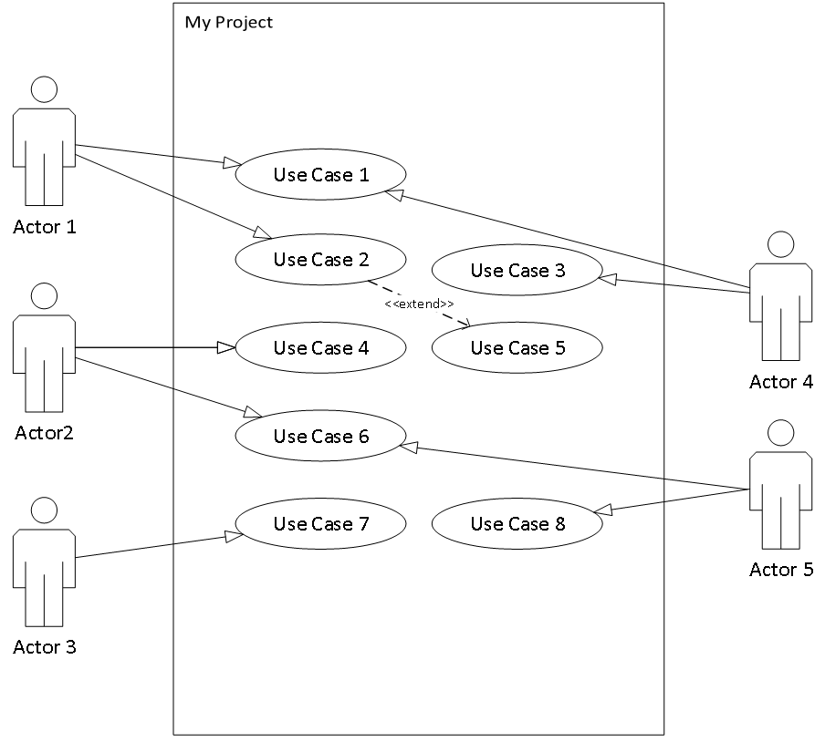

Figure 1: System Level Use Case Diagram

3.1. Use Case 1
ID | UC001
Name | Enroll Student
Description | Administrator enrolls a new student by capturing facial data.
Requirement(s) | FR001
Actor(s) | Administrator
Precondition | System is running, webcam is connected.
Postcondition | Student data and face encoding saved.
Basic Flow | Basic Flow  1. Admin selects “Enroll Student”.  2. Enters student details.  3. Captures face image via webcam.  4. System encodes and stores data.  5. Confirmation message shown.

Diagrams

Case :1

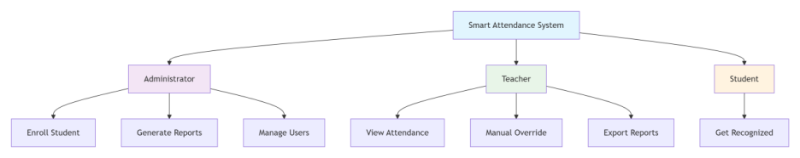

Case :2

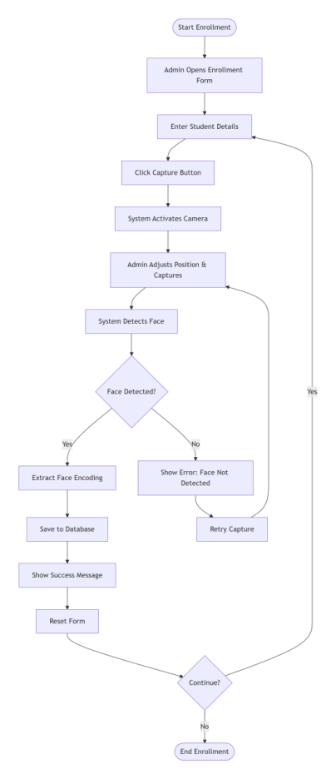

4. References

[1] A. K. Jain, P. Flynn, and A. A. Ross, Handbook of Biometrics, Springer, 2008.
[2] R. Brunelli and T. Poggio, “Face Recognition: Features versus Templates,” IEEE Trans. on PAMI, vol. 15, no. 10, pp. 1042–1052, 1993.
[3] D. E. King, “Dlib-ml: A Machine Learning Toolkit,” Journal of Machine Learning Research, vol. 10, pp. 1755–1758, 2009.
[4] OpenCV Documentation, https://docs.opencv.org
[5] face_recognition library, https://github.com/ageitgey/face_recognition

